Crime by Borough

Aim To determine if there is a link between the location of an area, and the number of crimes there are.

You are doing an investigation!

Step 1

Look at the spreadsheet produced by the PIB Crime Unit. This shows the different offences in London Boroughs in December 2008.
Choose which of the crimes you are going to report on.

YOU ARE GOING TO REPORT ON THEFT FROM SHOPS

Step 2

You are going to draw a choropleth map showing which boroughs have the most offences. A choropleth map is one that uses shading to show density of offences.

You will need to work out your own key for the map…

Example: 0 – 10 Green
11 – 30 Yellow
31 – 50 Orange
51 – 100 Red
101 and above Purple

Use different shades of similar colours to show the crimes increasing in areas that are shaded in darker colours.

Step 3

Shade in the boroughs on the map, in accordance with your key.

Step 4

Are there any patterns you can see?
Are there any areas that are far worse for crimes than others?
Is there a pattern between crimes and whether the houses are north or south of the river?
Is there anything else you found out that you didn’t know before?

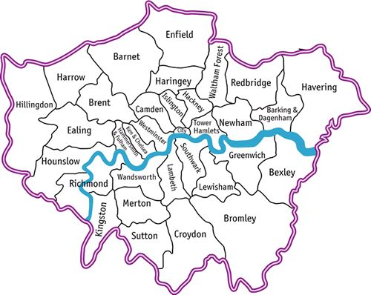
Produced by
Choropleth map showing ________________________ in London Boroughs
KEY

Are there any patterns you can see?
____________________________________________________________________________________________________________________________________________________________________________________________
Are there any areas that are far worse for crimes than others?
____________________________________________________________________________________________________________________________________________________________________________________________
Is there a pattern between crimes and whether the houses are north or south of the river?
____________________________________________________________________________________________________________________________________________________________________________________________
Is there anything else you have found out that you didn’t know before?
____________________________________________________________________________________________________________________________________________________________________________________________

