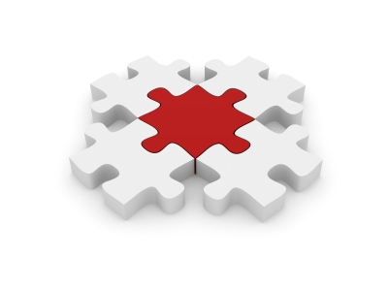
Integration
Horizontal integration occurs when one firm joins with another firm at the same stage of the production process. E.g. RBS bought Natwest in 2000.
Vertical integration occurs when one firm joins with another at a different stage of the same production process. This can be backward vertical integration, when a firm joins with its suppliers, or forward vertical integration, when a firm joins with its distributors. E.g. Pepsi bought KFC so it could sell its drinks there.
Conglomerate integration occurs when one form joins together with another firm in a different production process. E.g. Rentokil Initial’s businesses include office cleaning, security, pest control and parcel delivery.
- Explain why businesses use these different methods – what are their advantages?
................................................................................................................................................................................................................................................................................................................................................................................................................................................................................................................................................................................................................................................................................................................................................................................................................................................................................................................................................................................................................................................................................................................................................................................................................................................................................................................................................................................................................................................................................................................................................................................................................................................................................................................................................................................................
Advantages of integration
- Sharing ideas, experience, resources and skills
- Having more power and status in the market
- Horizontal integration can lead to economies of scale
- Vertical integration can ensure a firm keeps control of its supplies or distribution, which can improve reliability and quality and reduce costs
- Conglomerate integration can spread risks – a fall in demand in one market and be offset by growth in another
Disadvantages of integration
- Diseconomies of scale are the problems involved with controlling, communicating and motivating staff in a bigger business
- Culture clashes can occur because firms are used to doing things in different ways. E.g. Morrisons and Safeway. This can lead to arguments and inefficiency

- Why do you think there was a culture clash between Morrisons and Safeway?
................................................................................................................................................................................................................................................................................................................................................................................................................................................ ........................................................................................................................................................................................................................
- What are economies and diseconomies of scale?
................................................................................................................................................................................................................................................................................................................................................................................................................................................

