Organisational Structures within Business Organisations
Definition

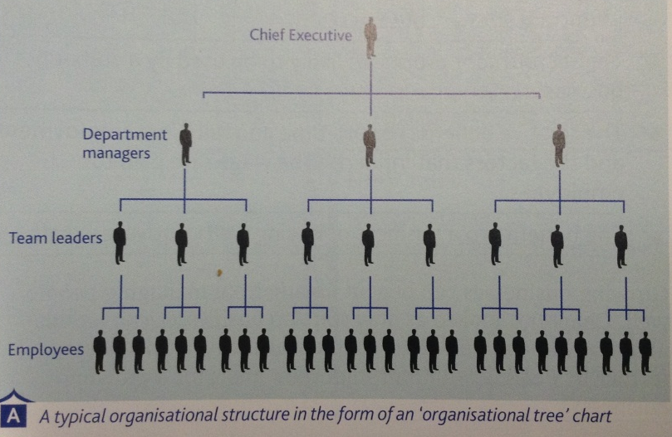

What are the Benefits of a business using an Organisational Structure?

Flat Organisational Structure Tall Organisational Structure

Two Advantages of a FLAT Organisational Structure: Two Advantages of a TALL Organisational Structure:

Two Disadvantages of a FLAT Organisational Structure: Two Disadvantages of a TALL Organisational Structure:

