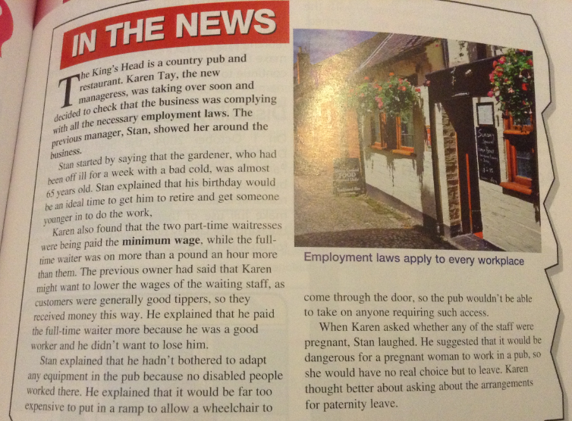
- Do you think the old owner was breaking any laws? Explain where and why.

- On what grounds can an employer discriminate against their staff?

