Employment Laws
Task: Match the laws to the definitions. Draw arrows to match them up.

The 1970 Equal Pay Act

The 1975 Sex Discrimination Act

The 1976 Race Relations Act

The National Minimum Wage Act 1988

The 1995 Disability Discrimination Act

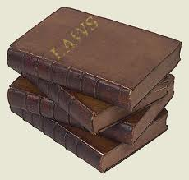

Requires that pay rates are the same for identical or similar jobs.
Outlaws discrimination on the grounds of colour, race, nationality and ethnic origin.
Gives everyone the right to a minimum amount to be paid depending on their age.
Makes it illegal for an employer to treat a disabled person less favourably for a reason which relates to the disabled person’s disability.
Makes it illegal for people to be discriminated against on the grounds of their gender.

