Sources of Finance

The information below may help with the following activity.
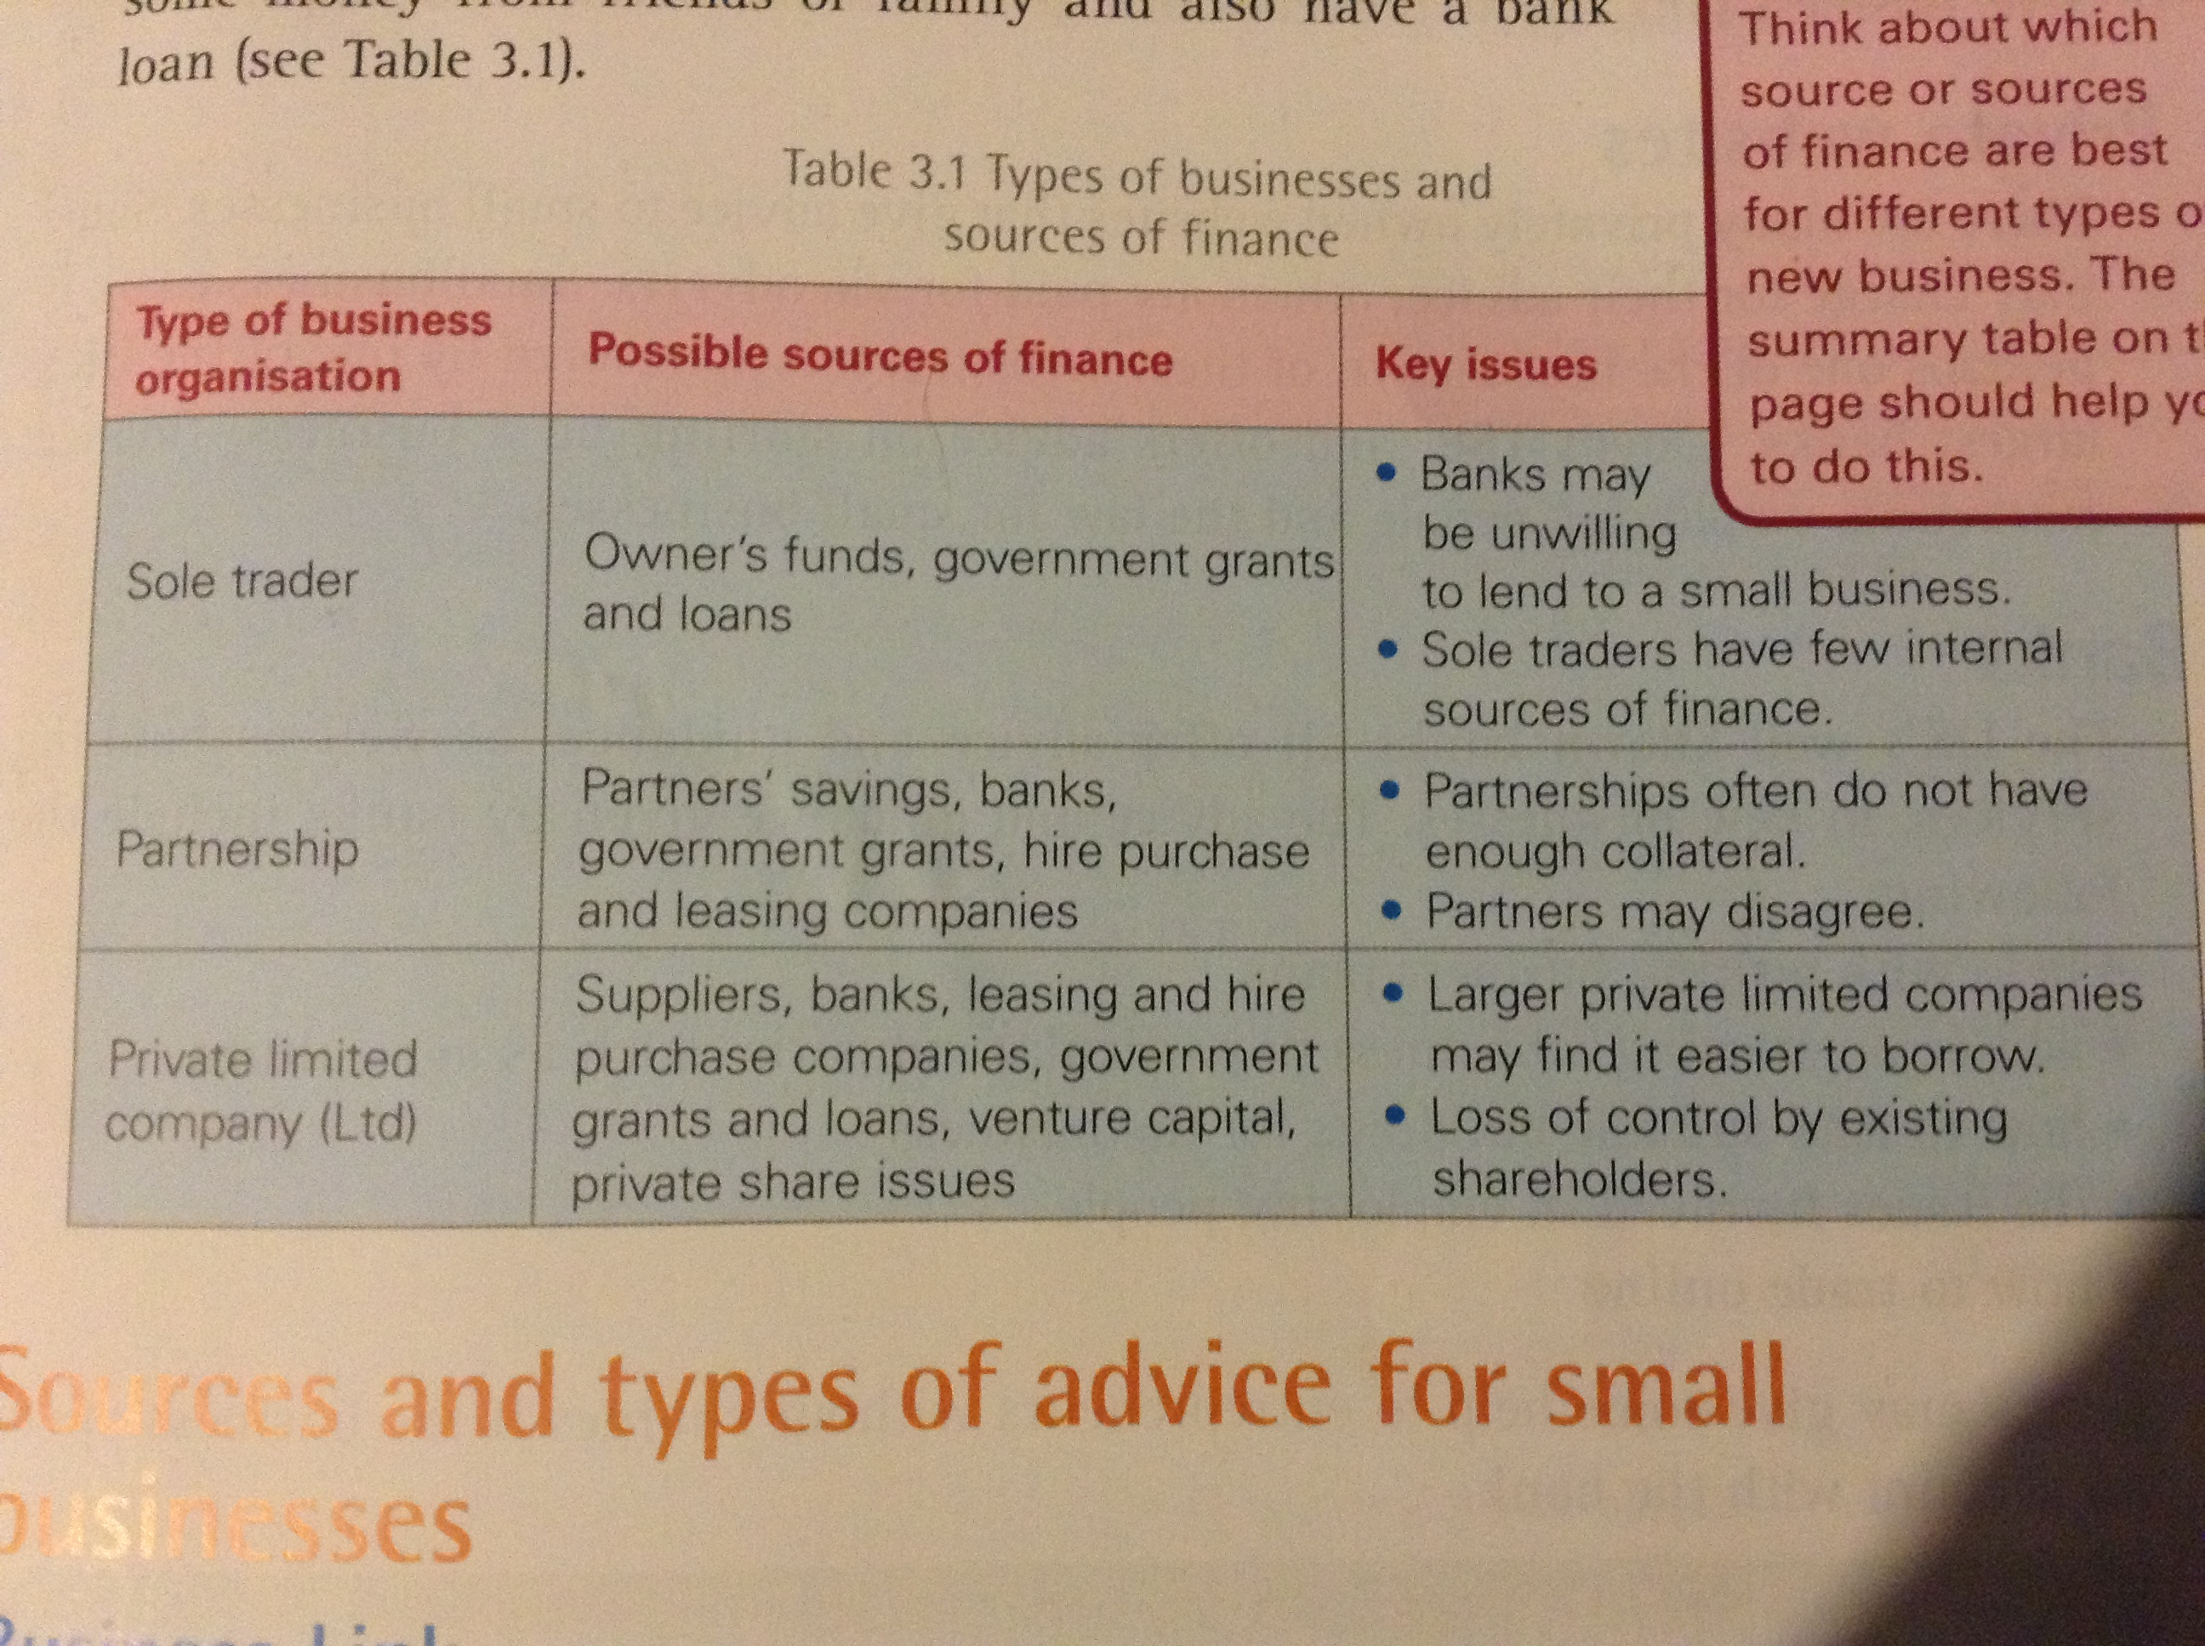
1. Why do you think banks may be unwilling to lend to small businesses?

2. What is interest?

3. What are the advantages and disadvantages of government grants?

4. Why do banks and building societies ask for security when giving mortgages?

5. Which do you think is the best source of finance to a new business and why?

